**Internship Report**

**WEB DEVELOPMENT**

**DLithe Consultancy Services Pvt. Ltd.**



**Internship Report**

**Trainee/Intern Name: Anirudh.S.Parastekar, Shravya.S.Devadiga.**

**Reg. no: 4MT21CS024, 4MT21CS150**

**Period:** **October 27-Nov 27**

**Job Assignment:** **Website creation**

**Organization:** **DLithe Consultancy Services Pvt. Ltd.**

**Supervisor’s Name: Ms. Archana**

**Observations:**

**Submitted to**

Signature of Training Supervisor Signature of Co-ordinator

Date: Date:

**Letter of Transmittal**

To,

Program Co-ordinator

DLithe Consultancy services

Bengaluru

Dear Sir,

We are writing to submit our report on Web Internship that we recently completed on Web development. The training program was an invaluable learning experience, and we are grateful for the opportunity to participate.

The training program covered various aspects of Website creation using HTML, CSS, Javascript, including basic concepts, algorithms, programming languages, and practical applications. We gained a comprehensive understanding of the role of web development in modern technology and industry, and also gained hands-on experience with web development tools and platforms. The training highlighted the potential of programming languages to revolutionize various fields, including advertising, finance, startups and manufacturing.

The report includes a detailed overview of the training program, including the topics covered, the learning objectives, and the outcomes achieved.

We believe that the knowledge and skills that we acquired during the training program will be valuable to our organization. The ability to work with web page creating tools and platforms will be increasingly important for our organization's success.

We hope that the report provides useful insights into the benefits of on-job training and the potential of Web development.

Sincerely,

Name: Shravya Devadiga, Anirudh.S.Parastekar

Reg. no: 4MT21CS150 ,4MT21CS024

**Table of Contents**

Introduction4

Background5

Project Overview5

Problem statement6

Solution

Methodology6

System requirements 6

Hardware requirement6

Software requirement6

Schematics and Code6

Results 6

Applications8

Literature survey8

Training Experience6

Key Learnings6

Challenges8

Conclusion8

**Introduction**

Web development is the magic behind every website and web application you encounter online. It's like building digital houses that people can visit, interact with, and do cool things in. Here's a quick intro to get you started:

**What is it?**

Web development is the process of creating and maintaining websites. It involves coding, designing, and making sure everything runs smoothly on the internet.

**The building blocks:**

* **Front-end:** This is what you see and interact with on a website. It's built using languages like HTML (structure), CSS (styling), and JavaScript (interactivity).
* **Back-end:** This is the hidden engine that powers the website. It uses languages like Python, Java, or PHP to process information, store data, and make the site functional.

**What can you build?**

* **Simple websites:** Informational pages, personal portfolios, blogs.
* **Web applications:** Online stores, social media platforms, interactive games.
* **Mobile apps:** Apps for your phone or tablet.

**Overview**

The Internship Training program on Web development that we participated in was conducted by a technology company. The program was designed to provide a comprehensive overview of Development of web applications, and to equip participants with the skills and knowledge required to build web applications.

The training program consisted of practical hands-on sessions. The lectures covered a wide range of topics, including the fundamentals programming, various techniques and algorithms used in web programming, and the latest developments in the web world. The practical sessions involved working on various projects and implementing the knowledge on real-world datasets.

**Project / Use Case implementation**

## Use Case: Exploring the Wonders of Google on Your Website

**Target Audience:** This website caters to everyone, from tech enthusiasts to curious newcomers, aiming to spark interest and understanding of Google's diverse offerings.

**Goal:**

* **Informative:** Effectively showcase Google's services, achievements, and awards in a clear, concise, and engaging way.
* **Interactive:** Encourage exploration and discovery through user-friendly navigation and captivating content.
* **Inspiring:** Highlight the positive impact of Google on individuals, communities, and the world.

**Possible Features:**

* **Interactive timeline:** Chart Google's milestones, starting from its humble beginnings to its current status as a global tech giant. Users can click on events to learn more about specific innovations or achievements.
* **Service spotlight:** Dedicate sections to popular services like Gmail, Drive, Classroom, Maps, Music, etc. Each section can offer:
  + **Interactive demos:** Show real-life examples of how each service works through short animations or screen recordings.
  + **Testimonials:** Feature quotes from satisfied users, highlighting the benefits of each service.
  + **Fun facts and trivia:** Inject some lightheartedness and encourage deeper engagement with hidden gems within each service.
* **Awards and accolades:** Display a dedicated gallery showcasing Google's prestigious awards and recognitions, along with brief descriptions of the achievements behind them.
* **Impact section:** Showcase Google's positive impact on the world through initiatives like Google.org, environmental sustainability efforts, and accessibility projects.
* **Future focus:** Briefly touch upon Google's forward-thinking projects in areas like Artificial Intelligence, quantum computing, and healthcare.

**Tools and Technologies Used:**

During the project, we used various tools and technologies such as:

Miro software: for creating the activity diagram like mind maps.

Visual Studio code: for creating and running the code.

Github: For uploading the project.

**Reference Images:**

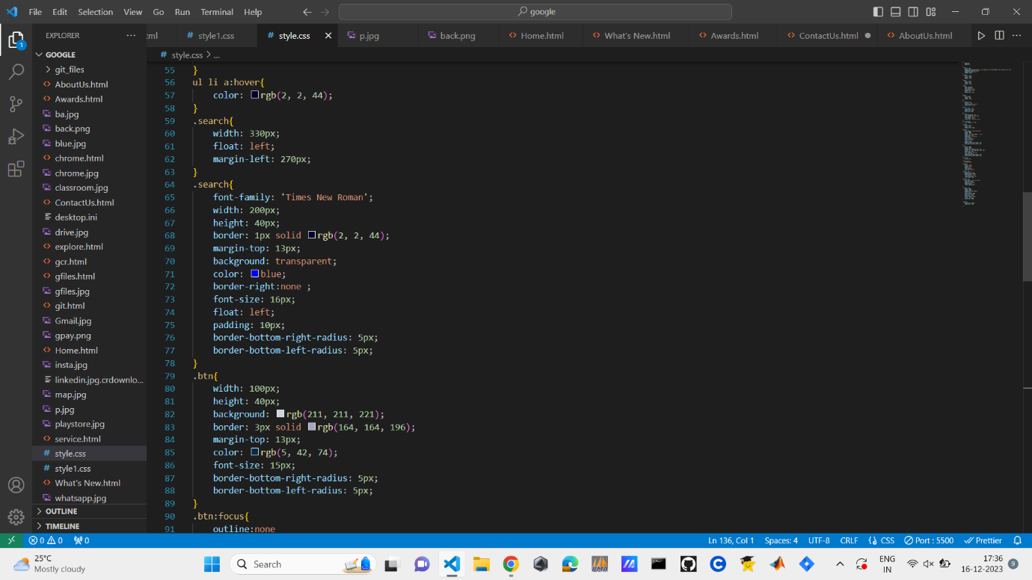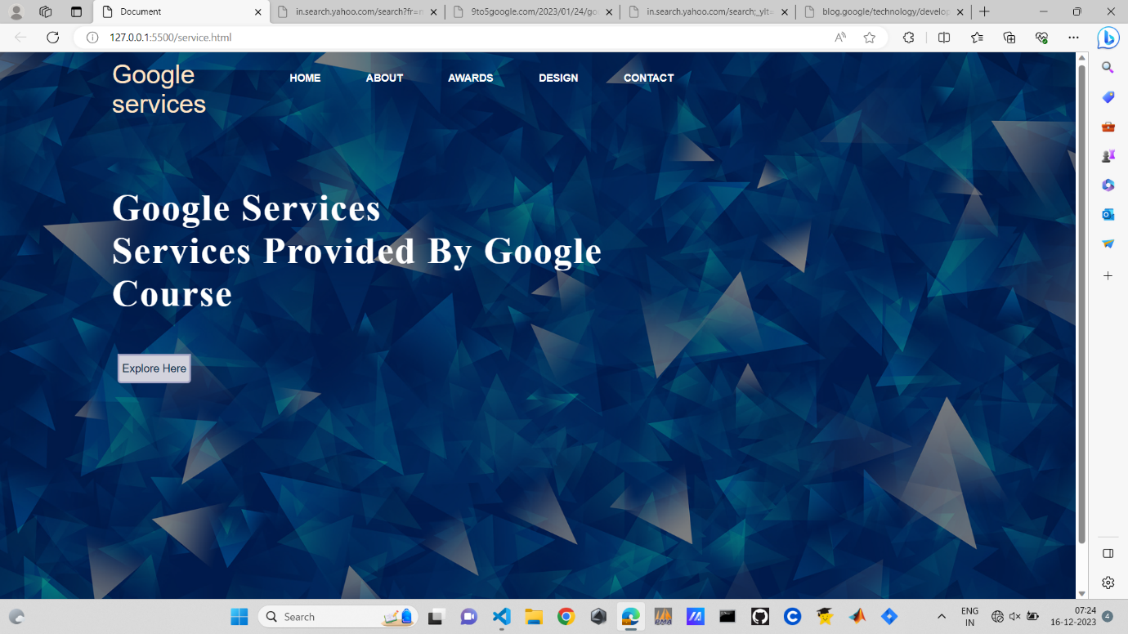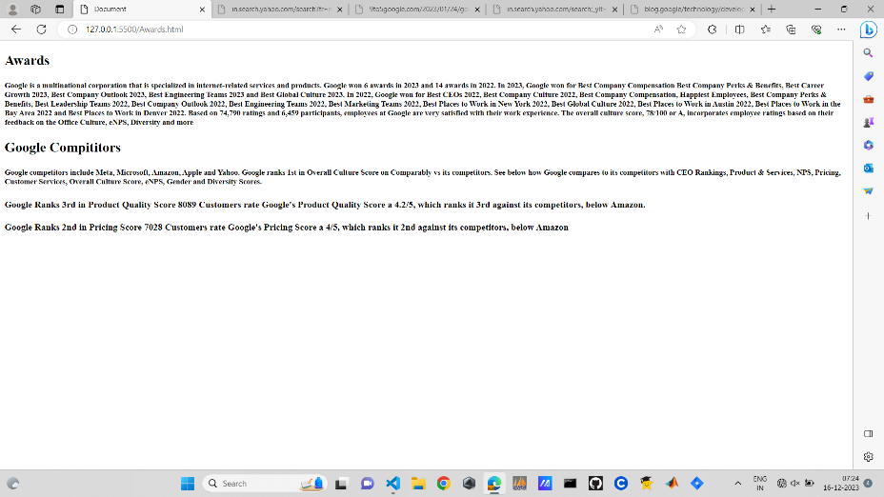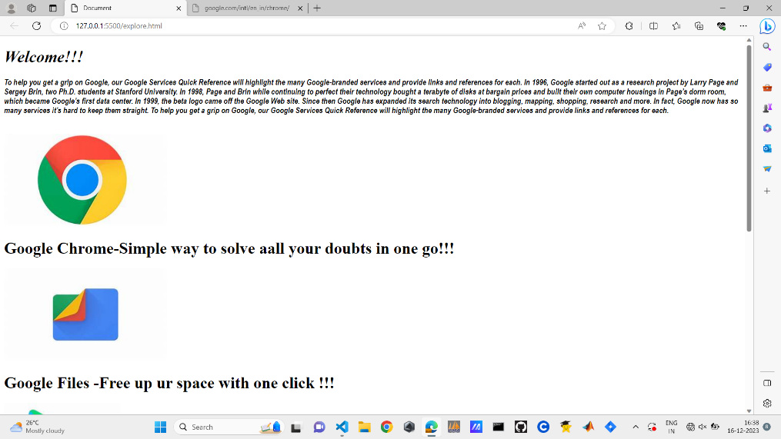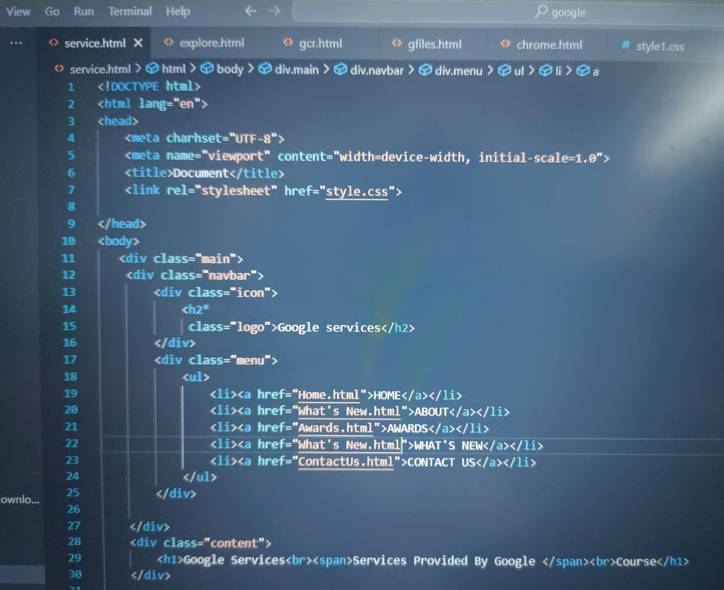

**Training Experience**

Hands-on Learning: Our training program was designed to provide hands-on experience with HTML, CSS, Javascript etc programming languages to create web pages. We were given the opportunity to work on real-world projects and problems, which helped us develop practical skills and apply theoretical concepts.

Mentorship: We were fortunate to have a mentor Ms.Archana who was an experienced Development of web applications professional. Our mentor Ms.Archana provided guidance, feedback, and support throughout my training program, which was invaluable in our learning journey.

Collaboration: One of the most exciting aspects of our training program was the opportunity to work with a team of professionals from different backgrounds. We collaborated on projects and shared ideas, which helped us develop our communication and collaboration skills.

Exposure to Industry Trends: We were able to stay up-to-date with the latest industry trends and developments in Web development and its applications through various workshops, seminars, and conferences. This helped us gain a broader perspective on the field and prepare for future challenges.

Use of Industry-standard Tools and Technologies: During my training, I had the opportunity to work with industry-standard tools and technologies such as VS code, NodeJS, Jira software etc. This allowed me to gain practical skills that are in demand in the industry.

Iterative Process: I also learned that developing an Web application is an iterative process that requires a lot of experimentation and tweaking. It is essential to have a feedback loop that allows for continuous improvement of the model.

**Observations:**

During my on-job training on Web Development, I was able to observe several important things. Here are my observations:

Importance of Structured programming : The success of web applications or web pages heavily depends on structure and the effectiveness available for training. Without that, it is difficult to build accurate and effective web pages. Therefore, Structured programming is a critical step in creating web applications.

Diversity of Applications: Development of Web can be applied in various domains, from businesses to finance, from retail to transportation. The applications are diverse and endless, and the potential impact of web programming on society is enormous.

Algorithm Selection: There is no one-size-fits-all algorithm for programming. The choice of algorithm depends on the specific problem being solved, and the desired output. It is crucial to have a good understanding of different algorithms and their strengths and weaknesses.

Ethical Considerations in Web Development:

* Accessibility: Websites should be accessible to everyone, regardless of ability. This means considering visual impairments, hearing impairments, cognitive disabilities, and more. For instance, using alt text for images and transcripts for videos ensures everyone can access the information.
* Privacy: User privacy is paramount. Websites should clearly communicate how they collect and use data, and obtain informed consent from users. Implementing strong data security measures is also essential.
* Security: Websites have a responsibility to protect user data from security breaches and cyberattacks. Regular updates, secure coding practices, and vulnerability testing are crucial.
* Content moderation: Websites that allow user-generated content need to balance freedom of expression with preventing harmful content like hate speech and misinformation. Clear guidelines and effective moderation processes are necessary.

Biases in Web Development:

* Algorithmic bias: Algorithms used in website personalization, search engines, and recommendation systems can perpetuate existing biases in society, such as racial or gender bias. It's crucial to audit and mitigate these biases in data and algorithms.
* Confirmation bias: Developers, like everyone else, can be susceptible to confirmation bias, favoring information that confirms their existing beliefs. This can lead to overlooking diverse perspectives and creating websites that cater to a specific group.
* Unconscious bias: Unconscious biases, ingrained societal prejudices, can unintentionally influence design choices, language use, and overall website tone. Developers need to be aware of their own biases and actively work to counteract them.

Importance of Visualization: Visualization is a powerful tool for exploring and understanding web applications. It can help identify patterns and trends in the data, which can be used to improve the application’s performance.

Role of Domain Experts: Domain experts play a critical role in the development web applications. They have a deep understanding of the problem and the programming, which can help identify the right features and improve the page's performance.

Importance of Communication: Effective communication is critical when working with cross-functional teams. Clear communication of goals, expectations, and results is essential for success.

**Key Learnings**

During the training program, I learned a range of skills and concepts related to Web development. Some of the key skills that I acquired are:

Understanding of programming: I gained a comprehensive understanding of programming languages, including the various programming languages such as HMTL, CSS, Javascript, ReactJS, NodeJS.

HTML an CSS: These two programming languages are the main part of the front end development of web applications. Along with these we use Javascript to make it more clear and make it user interface.

Programming Skills: I developed strong programming skills in HTML, CSS, Javascript after this internship.

**Web Applications used in real world**

**E-commerce:** The vast online marketplace wouldn't exist without e-commerce platforms built by web developers. From giant retailers like Amazon to local shops with online stores, web development powers the entire shopping experience, from browsing products to secure checkout.

**Social media:** Platforms like Facebook, Twitter, and Instagram, where we connect and share, are all products of web development. Building features that facilitate communication, manage user data, and personalize experiences relies heavily on developers' skills.

**Education:** The rise of online learning has been bolstered by educational websites and platforms built by web developers. Interactive courses, virtual classrooms, and learning management systems all utilize web development to make education accessible to people everywhere.

**Entertainment:** Gaming, streaming services, and interactive entertainment experiences all rely on web development. Building immersive online worlds, managing user accounts, and delivering content flawlessly involve complex back-end and front-end development.

**Healthcare:** Telemedicine, patient portals, and medical data management systems are just some examples of how web development is transforming healthcare. Secure platforms for communication, appointment scheduling, and data storage are crucial for modern medical practices.

**Non-profit and Social Impact:** Web development helps non-profit organizations reach wider audiences, raise funds, and connect with supporters. Building donation platforms, advocacy websites, and online resources empowers these organizations to make a positive impact.

**Personal Tools and Services:** From online banking and budgeting apps to project management tools and personal websites, web development enables us to manage various aspects of our lives through convenient online platforms.

**Conclusion**

The services provided by google project was a valuable learning experience that allowed me to apply my knowledge of web programming in a real-world setting. I gained hands-on experience with various programming languages, algorithms, and other tools. Overall, the project helped me develop practical skills that are in demand in the IT industry.

Overall, my Internship Training experience on Development in web applications was extremely valuable. I gained a solid understanding of the fundamental concepts and techniques in the field, and developed strong programming skills. The hands-on projects that I completed during the training gave me a real-world experience of implementing the codes on real world problems. I am confident that the skills and knowledge that I acquired during the training will be invaluable in my future career as a full stack developer, front-end developer etc.